Domayne’s Silver detailed Dining Set

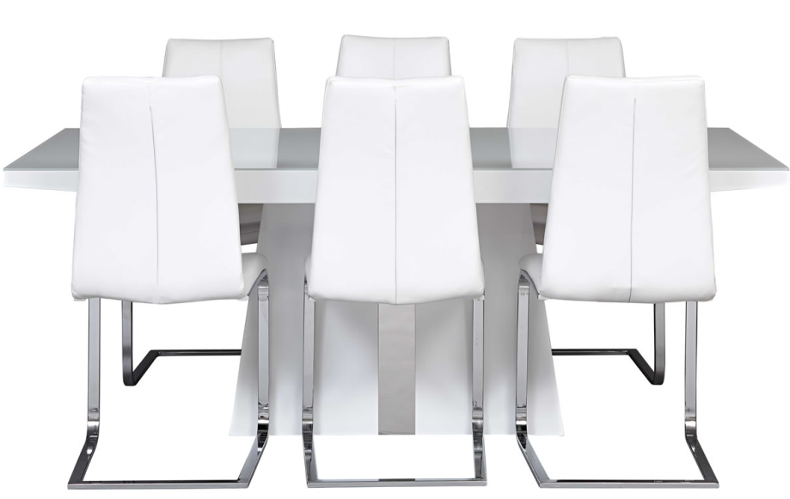

|  |
| --- |
| **DESCRIPTION** |
| Domayne introduces stylish steel dining set with a rich silver glowing finish on top the set of tables and chairs is perfect to create the perfect the lighting surrounding. The rich stainless steel with mirror silver on top gives you feeling of large decorating piece. Perfect for party environment. |

|  |  |  |
| --- | --- | --- |
| **Price** | **1270$** | |
| **Dimensions** | **Table H** x **W** x **L** | **45in x 35in x 45in** |
| **Chairs H** x **W** x **L** | **30in x 24in x 28in** |
| **Features** | **Six Chairs and One Table with on top and bending balanced legs will help to adjust according to the weight** | |
| **Finished** | **Mirror Silver** | |
| **Available in** | **Silver, Chrome and Opaque purple** | |